**Practice 4.1 (Composite Data Types)**

1. Within the PL/SQL block create a record to store information about yourself: name, year of birth, place of birth. Output the information to the screen.

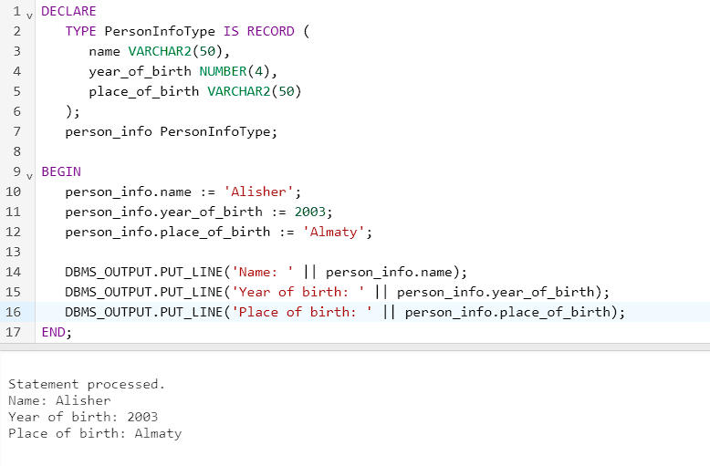

DECLARE

TYPE PersonInfoType IS RECORD (

name VARCHAR2(50),

year_of_birth NUMBER(4),

place_of_birth VARCHAR2(50)

);

person_info PersonInfoType;

BEGIN

person_info.name := 'Alisher';

person_info.year_of_birth := 2003;

person_info.place_of_birth := 'Almaty';

DBMS_OUTPUT.PUT_LINE('Name: ' || person_info.name);

DBMS_OUTPUT.PUT_LINE('Year of birth: ' || person_info.year_of_birth);

DBMS_OUTPUT.PUT_LINE('Place of birth: ' || person_info.place_of_birth);

END;

/

2. Write a PL/SQL block to print information about a given country.

a. Declare a PL/SQL record based on the structure of the countries table.

b. Define a variable countryid and pass the value througha substitution variable.

1. In the executable section, get all the information from the countries table by using countryid. Display selected information about the country. A sample output is shown below.
2. You may want to execute and test the PL/SQL block for the countries with the IDs DE, UK, US.

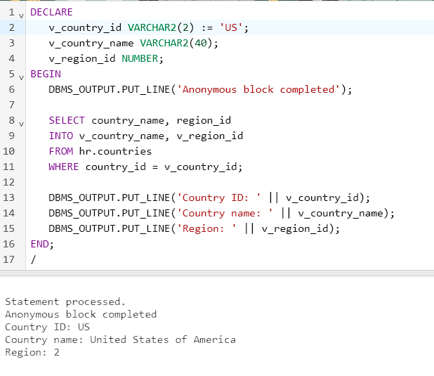

DECLARE

v_country_id VARCHAR2(2) := 'UK';

v_country_name VARCHAR2(40);

v_region_id NUMBER;

BEGIN

DBMS_OUTPUT.PUT_LINE('Anonymous block completed');

SELECT country_name, region_id

INTO v_country_name, v_region_id

FROM hr.countries

WHERE country_id = v_country_id;

DBMS_OUTPUT.PUT_LINE('Country ID: ' || v_country_id);

DBMS_OUTPUT.PUT_LINE('Country name: ' || v_country_name);

DBMS_OUTPUT.PUT_LINE('Region: ' || v_region_id);

END;

/

1. Within a PL/SQL block create an INDEX BY table to store the square of the numbers from 1 to 8. Output the result to the screen.

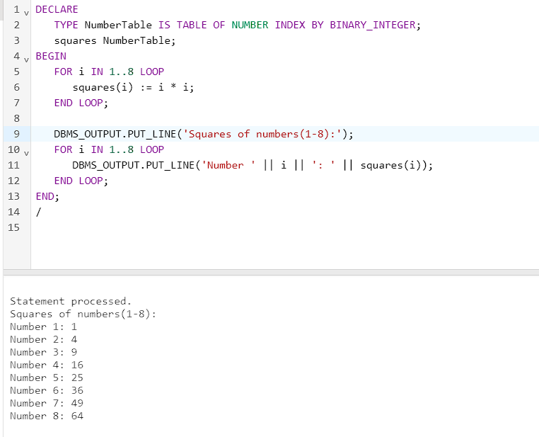

DECLARE

TYPE NumberTable IS TABLE OF NUMBER INDEX BY BINARY_INTEGER;

squares NumberTable;

BEGIN

FOR i IN 1..8 LOOP

squares(i) := i * i;

END LOOP;

DBMS_OUTPUT.PUT_LINE('Squares of numbers(1-8):');

FOR i IN 1..8 LOOP

DBMS_OUTPUT.PUT_LINE('Number ' || i || ': ' || squares(i));

END LOOP;

END;

/

4. Create a PL/SQL block to retrieve the names of some departments from the departments table and print each department name on the screen, incorporating an INDEX BY table. Using a loop, retrieve the names of 10 departments and store the names in the INDEX BY table. Start with department_id 10. Increase deptno by 10 for every iteration of the loop. The following table shows the department_id for which you should retrieve the department_name and store in the INDEX BY table. Using another loop, retrieve the department names from the INDEX BY table and display them.



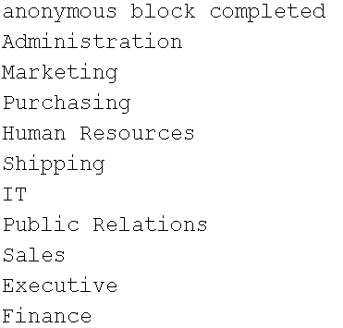

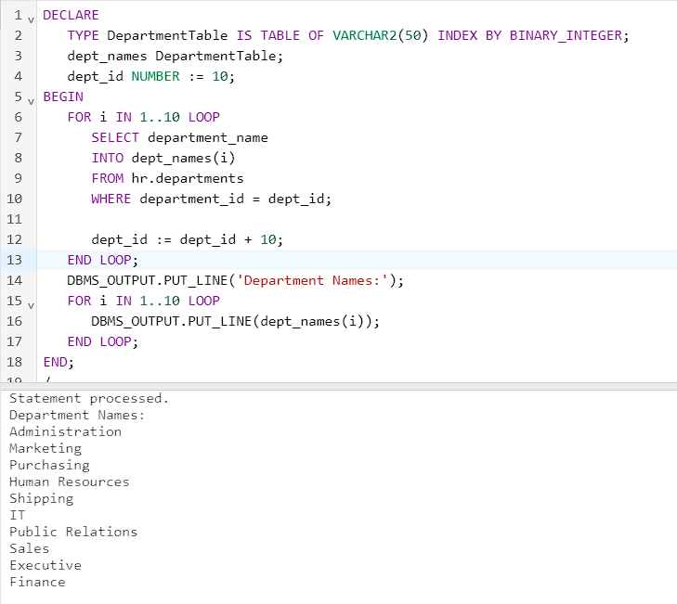

DECLARE

TYPE DepartmentTable IS TABLE OF VARCHAR2(50) INDEX BY BINARY_INTEGER;

dept_names DepartmentTable;

dept_id NUMBER := 10;

BEGIN

FOR i IN 1..10 LOOP

SELECT department_name

INTO dept_names(i)

FROM hr.departments

WHERE department_id = dept_id;

dept_id := dept_id + 10;

END LOOP;

DBMS_OUTPUT.PUT_LINE('Department Names:');

FOR i IN 1..10 LOOP

DBMS_OUTPUT.PUT_LINE(dept_names(i));

END LOOP;

END;

/

**Practice 4.2 (Explicit Cursors)**

1. Create a PL/SQL block that determines the top *n* salaries of the employees.

* + - 1. Create a table top_salaries with one column salary of the type NUMBER(8, 2).
      2. Declare a number *n* that represents the number of top *n* earners from the employees table.
      3. Declare a variable sal of type employees.salary.
      4. Declare a cursor, emp_cursor, that retrieves the salaries of employees in descending order. Remember that the salaries should not be duplicated.
      5. In the executable section, open the loop and fetch top *n* salaries and insert them into top_salaries table. You can use a simple loop to operate on the data. Also, try and use %ROWCOUNT and %FOUND attributes for the exit condition.
      6. After inserting into the top_salaries table, display the rows with a SELECT statement. The output shown represents the five highest salaries in the employees table.

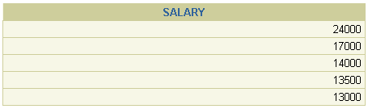

* + - 1. Test a variety of special cases, such as *n* = 0 or where *n* is greater than the number of employees in the employees table. Empty the top_salaries table after each test.

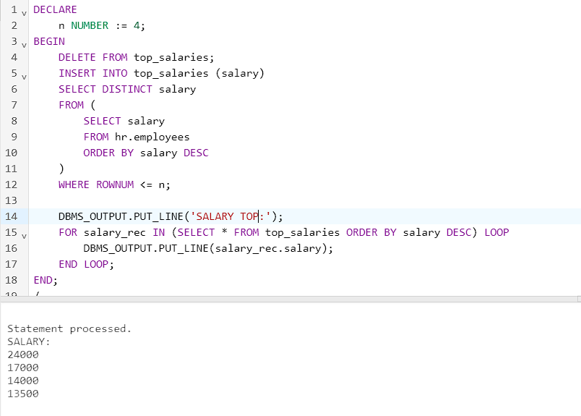

DECLARE

n NUMBER := 4;

BEGIN

DELETE FROM top_salaries;

INSERT INTO top_salaries (salary)

SELECT DISTINCT salary

FROM (

SELECT salary

FROM hr.employees

ORDER BY salary DESC

)

WHERE ROWNUM <= n;

DBMS_OUTPUT.PUT_LINE('SALARY TOP:');

FOR salary_rec IN (SELECT * FROM top_salaries ORDER BY salary DESC) LOOP

DBMS_OUTPUT.PUT_LINE(salary_rec.salary);

END LOOP;

END;

/

1. Create a PL/SQL block that outputs all employees from the department 60 and with the salary more than 5000.

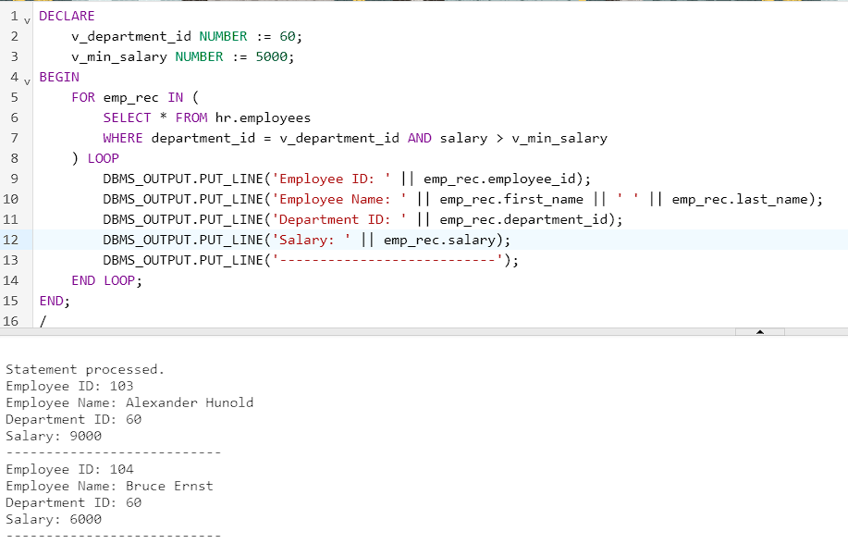

DECLARE

v_department_id NUMBER := 60;

v_min_salary NUMBER := 5000;

BEGIN

FOR emp_rec IN (

SELECT * FROM hr.employees

WHERE department_id = v_department_id AND salary > v_min_salary

) LOOP

DBMS_OUTPUT.PUT_LINE('Employee ID: ' || emp_rec.employee_id);

DBMS_OUTPUT.PUT_LINE('Employee Name: ' || emp_rec.first_name || ' ' || emp_rec.last_name);

DBMS_OUTPUT.PUT_LINE('Department ID: ' || emp_rec.department_id);

DBMS_OUTPUT.PUT_LINE('Salary: ' || emp_rec.salary);

DBMS_OUTPUT.PUT_LINE('---------------------------');

END LOOP;

END;

/

3. Rewrite the script of the task 2 using Cursor FOR Loop.

4. Create a PL/SQL block that does the following:

* + - 1. Define a variable deptno to provide the department ID.
      2. Declare a cursor, emp_cursor, that retrieves the last_name, salary, and manager_id of the employees working in the department specified in deptno.
      3. In the executable section use the cursor FOR loop to operate on the data retrieved. If the salary of the employee is less than 5000 and if the manager ID is either 101 or 124, display the message <<*last_name*>> Due for a raise. Otherwise, display the message <<*last_name*>> Not due for a raise.
      4. Test the PL/SQL block for the following cases:



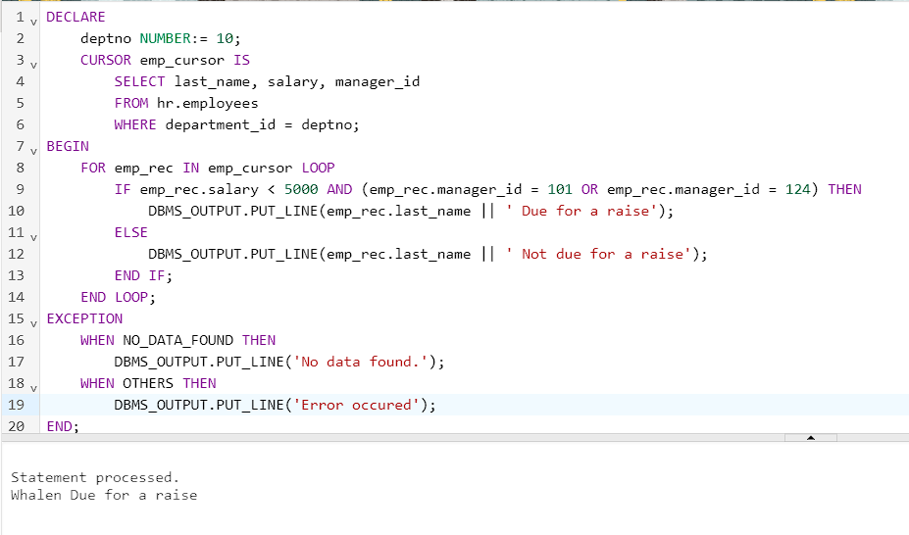w

5. Write a PL/SQL block, which declares and uses cursors with parameters. In a loop, use a cursor to retrieve the department number and the department name from the departments table for a department whose department_id is less than 100. Pass the department number to another cursor as a parameter to retrieve from the employees table the details of employee last name, job, hire date, and salary of those employees whose employee_id is less than 120 and who work in that department.

* + - 1. In the declarative section, declare a cursor dept_cursor to retrieve department_id, department_name for those departments with department_id less than 100. Order by department_id.
      2. Declare another cursor emp_cursor that takes the department number as parameter and retrieves last_name, job_id, hire_date, and salary of those employees with employee_id of less than 120 and who work in that department.
      3. Declare variables to hold the values retrieved from each cursor. Use the %TYPE attribute while declaring variables.
      4. Open the dept_cursor, use a simple loop and fetch values into the variables declared. Display the department number and department name.
      5. For each department, open the emp_cursor by passing the current department number as a parameter. Start another loop and fetch the values of emp_cursor into variables and print all the details retrieved from the employees table. **Note:** You may want to print a lineafter you have displayed the details of each department.Use appropriate attributes for the exit condition. Also determine whether a cursor is already open before opening the cursor.
      6. Close all the loops and cursors, and end the executable section. Execute the script.

The sample output is shown below.

